
Wii Design Proposal

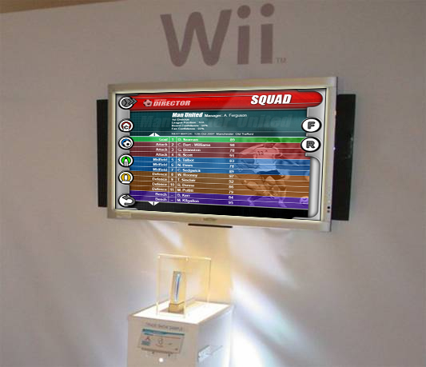

Created: 24th October 2007 - Version: 0.1

Author: Simon Barratt

Football Director is the property of Sports Director Limited.

Contact Details
For further information on this document or Four Door Lemon Ltd, please contact:

Simon Barratt
simon@fourdoorlemon.com
+44 (0)870 1241215

Game Overview

Football Director is a football management game aimed at casual gamers new to management games as well as providing tactical and strategic depth that an experienced management gamer can appreciate.

This document outlines possible screen layouts and control systems for this game being transferred from the Pocket PC and Nintendo DS onto the Nintendo Wii and further home consoles.

Features

Standard Features (some of which as featured in Nintendo DS version)

- Addictive strategic and tactical play
- Watch the match unfold with exciting commentary and hear the crowd respond to your teams performance.
- Spot upcoming youth team players and train them to their full potential.
- Manage and negotiate player and employee wages to control the clubs wage structure.
- Control the training of the squad and focus them on specific formations or set pieces to allow your team to play out your tactics to your desire.
- Control the finances and borrowing of the club to allow investment in new players and employees.

WII / Console Specific Features

- Control any major European league club (including English, Spanish, Italian, German and Scottish leagues)
- Access players and teams from all major European leagues and major teams from the Rest of the World.
- Multiplayer – HotSeat
  - Football Director may be played by upto 4 players on a single Wii, each day the control of the game will start with user 0, when he is ready to proceed to the next date he will select 'end turn' and control will then switch to user 1, and so on upto the number of active users, when the last user has indicated he is ready to progress then the game will proceed and process the matches etc.
- Scenarios
  - Challenges are presented for the player to achieve given a certain starting team and set of limits. See more details below
- Multiple Playable Nations
  - In Football Director on DS, it is only possible for 1 nation to be fully active, but with the extra memory and processing power available on the Wii it will be possible for all the major nations to be fully active simultaneously, and each user could play in different countries if they so wished.
- Managerial Hall of Fame
  - Monitor your progress up the leaderboard of managers of all time based on your performance at each club and how you progressed them.
- Graphic representation of player ratings / skills
  - To provide a simpler less scary interface with lots of number based ratings stars or colour grading will be used for players skills.
- Transfer / Career history
  - With the extra storage memory available details of players and employees past clubs will be kept throughout the active game.
- In-game match play
  - Watch a top down view of the match as the players run around the pitch, pass the ball around and hopefully score your team a goal!
- Up to 4 games in progress at once
  - Switch between multiple games, manage Manchester United in one game and a scenario involving Doncaster Rovers in the other. This removes the restriction on the DS version of the game of having to end and remove your current game when you want a change.

Scenario Feature

A scenario is like a mission or challenge where the user is given a club to manage and within a specified period of time(usually a single season) must achieve the specified objectives. Playing in this mode will be single player only, but he will be able to select any playable nation, but not the club as this club will have its squad and financial status modified to suit the scenario objectives. A master screen will be available within the user's profile detailing which scenarios he has completed.

Example scenarios

Sleeping Giant
Grab control of a club languishing in the lower regions of the 2nd Division. With a limited cash injection of £15,000,000, can you get the club into the Premiership where it belongs and qualify for the UEFA Cup, or better, in 3 seasons?

Pennies from heaven
For too many years your team has been an also-ran. Once a proud team but now the news of yester-year. A wealthy new director decides to inject £25,000,000 into the coffers.. your quest, to win the Premiership title within 3 years starting from the 1st Division.

The Double
Your team has emerged as one of the leading lights of the Premiership. With a strong, motivated squad, can you win the double of League & FA Cup? You have only 1 season to do it in and only £10,000,000 in the bank.

Clean Sweep
Could your team do as no other? Win the League, League Cup, FA Cup and UEFA Cup in one season? An impossibility? With such a strong squad, the odds might just be in your favour. 1 Season only, £15,000,000 in the bank.

Screen Design

The general style of the screens has been kept similar to the Nintendo DS version of the game to establish a common look of the Football Director brand across the two platforms. Where the news / status screens on the DS are split across the two LCD screens on the Wii with a single larger display the status is shown below the news bar.

The menu system on the left of the screen provides access to all areas of the game, the player will hover the cursor over the relevant menu icon which will then expand out to provide further icons which can be selected to access a new screen. The news items can be expanded using the + button next to the relevant article and the news list can be scrolled using the scroll buttons on screen or using the controller.

The top left button lets the player move the game time forward, the game will choose whether to move forward a single day or to the next match depending on the news items which occur during that time. The bottom left button is a back button which when the player goes several screens deep investigating a team can be used to move back up to the screen they were previously on.

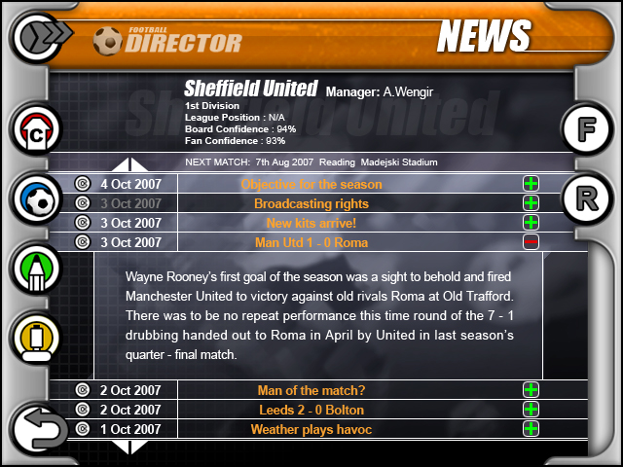

Below is the squad screen used to arrange the first 11, the substitutes and players not involved in the playing squad. From here the player can set the formations and player roles as well as access the rest of the management screens.

Please note that the status information below the ‘SQUAD’ title is likely to be removed to give even more screen space.

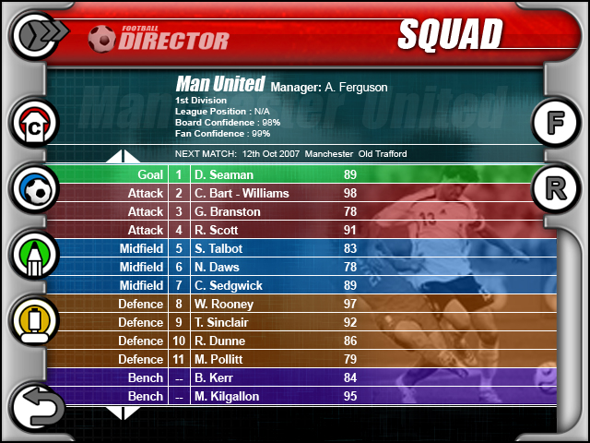

Control System

The game is controlled with the Wiimote cursor for the majority of screens which is as simple to control as pointing at the screen, when the user moves the cursor over an interactable option the Wiimote will vibrate and make a sound through its speaker to indicate a valid option.

The previous screen be returned to with either the back button in the corner of the screen or by pressing the ‘B’ button.

None of the extension controls such as the nunchuk are used.

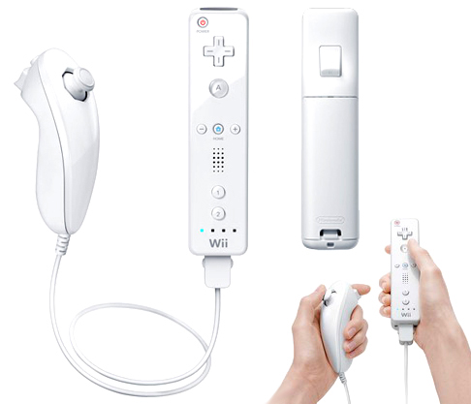
[B] Button
Move back to previous screen
(-) & (+) Buttons
Can be used as an alternative to adjust values
[A] Button
Used to select a button or drag an item

Development Schedule

The development work for these features and the implementation of the layouts and controls on the Wii will take roughly 6 months to gold this will include testing of the new features and data. Please note this is based on the current feature set and will be subject to negotiation.

